Multi Linear Regression Documentation

Business Problem:

Prediction of profit of different startup companies.

Objective:

Prepare a prediction model for profit of 50_startups data.

Exploratory data Analysis:

Data set contain 50 rows and 5 column entries. It contains the amount of money spent in R&D, Administration, Marketing and profit of different countries around different states of USA.

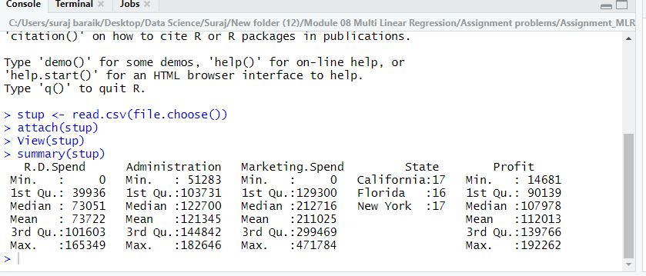

Plots and correlation

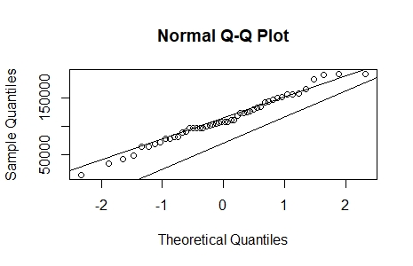

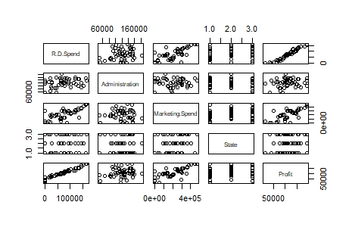

Removing Column name State

cor(setup) cannot execute as the column name state doesn’t contain numeric value

#### Linear Model of interest, excluding the column name "State"

### lm(Y~ X1+X2+X3)

model.stup <- lm(Profit ~ R.D.Spend + Administration + Marketing.Spend)

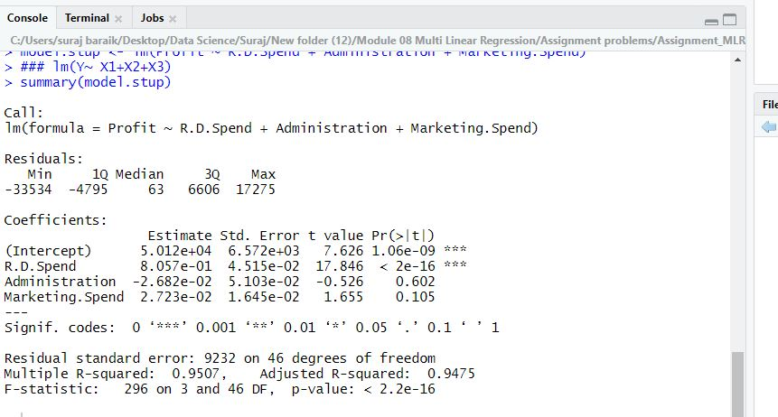

model.stupRD <- lm(Profit ~ R.D.Spend)

summary(model.stupRD)

#### p value is less than 0.05 with ***, so it is strongly signioficant

model.stupAd <- lm(Profit ~ Administration)

summary(model.stupAd)

Plots

